The 2007-08 Year-End Budget Review is intended to provide the campus with open, timely, relevant and comprehensive information on UW-Stout's budget and personnel activity.

This report to the campus provides information concerning the first year of the 2007-2009 UW System biennial budget and its impact on UW-Stout. Highlights for 2007-08 include:

- State tax dollars and student tuition fund 59% of total university expenditures.
- Direct student support accounted for 64% of Stout’s total expenditures, including instruction, academic support, financial aid and student services.
- UW-Stout, like the other UW institutions, received a 2.0% pay plan.
- UW-Stout generated $42 million in tuition revenue for the fiscal year.
- Construction started on the Jarvis Hall Science Wing Renovation and Addition project
- 1,476 total scholarships (including outside sources) were awarded for a total of $2,252,795.
- Stout students received $56.2 million in student financial aid.

The tables and graphs display budget and expenditure information, and add context by showing a history or trends and providing comparative data from UW System comprehensive universities.

ALL FUND SUMMARY (pages 5 – 10)

General Program Operations, Program Revenue and Program Revenue Federal are the three major categories of funding support for UW-Stout. Definitions of these terms and of the specific appropriations can be found in the Glossary. UW-Stout's 2007-08 final year-end budget totaled just over $153.4 million.

- State tax dollars and tuition continue to be the primary source of funds for the university. Tuition, however, went from 20.1% of the total in 1987-88 to 32.4% in 2007-08. Program Revenue has increased slightly from 22.4% in 1987-88 to 22.6%. Program Revenue Federal decreased by 3.6 percentage points since 1987-88.

- Summary of Expenditures by accounting classification indicates a decrease of nearly 1.6 percentage points in the proportion of funds for salaries and fringe benefits combined. Stout continues to exceed the System average of 56.4% by 3.3 percentage points at 59.7%.

- Services and Supplies increased as a percentage of total expenditures to 30.3%, which is 4.3 percentage points higher than the comprehensive average. Capital expenditures are up over $893,000 from 2006-07 and above the comprehensive average of 1.5%. Together, they comprise 32.4% of total expenditures, an increase of 2.1 percentage points since last year.

- The summary of expenditures by activity shows that 64% of UW-Stout's total expenditures were for direct student support (instruction, academic support, financial aid, and student services).

GENERAL PROGRAM OPERATIONS (pages 11 – 56)

The 102 appropriation is the main source of funding for instruction, academic support and institutional support. This section also includes the 131 appropriation or academic student fees including customized instruction and access to learning.

- The Statement of 102 Changes indicates UW-Stout's 102 budget increased by $2,700,036 during the fiscal year. Increases in the 102 budget included $39,551 for PK-16 Teacher Quality Initiative Grant, $75,000 for COBE Grant (Council on Baccalaureate Expansion) and carryover from 2006-07 represented just over $2,544,000.

- For almost all activities (102/131 expenditures by activity) expressed as a percent of total 102 expenditures, Stout remains relatively close to the comprehensive average; usually within one percent in all activities. Instruction is the exception with Stout at 58.6% and the comprehensive average at 56.9%.

- Expenditures associated with Institutional Support (10.9%, up 1% from 06-07)) still remain near the comprehensive average (10.6%) of total 102/131 expenditures. For 7 years Stout was below the comprehensive average. In 1998-99 Stout's Institutional Support was 13.4% of the total 102 expenditures for that year, a decrease of nearly 3 percentage points. The decrease can be attributed to the distribution of Technology and Information Services (TIS) expenditures from institutional support to the departments, which received the services and supplies starting in 1999-00. The TIS distribution method is in accordance with UW System Attachment 2, Distribution of General Support Services Costs and Distribution of Academic Computing Costs. The distribution of these expenditures helps to bring Stout more in line with other UW institutions for comparability purposes on activity cost data.

- FTE enrollment for fall 2007 reached its highest level of 7,320 FTE (including customized instruction). Headcount was also at its highest level at 8,477.

- Stout generated $42.1 million in tuition revenue in 2007-08 (includes customized instruction and Access to Learning).

- The 2006-07 Student Technology Fee project allocations included $125,000 for Student SAN Supporting File and Data Storage, $72,003 for Lynda.com online training videos, and $95,000 for wireless network upgrade.

- UW-Stout remains below the comprehensive average by approximately 6.5% in both SCH/FTE and Student to Staff Ratio.

- Overload payments increased from 2006-07 to 2007-08 by 11%, or nearly $109,000. Excluding Winterm the increase was just 1.4% or $11,643. Overloads for 2007-08 came to a total of $1,118,240, which is the highest total over the past six years. Dollars paid in overloads have increased annually for the past 5 years.

- During the past year, 245 computers (185 laptops and 60 desktops) for faculty, academic staff and classified staff were purchased at a total cost of $509,974. Since the program was started in 1995-96, 2,547 computers have been purchased at a total cost of $6,733,231.

- Construction of the Jarvis Hall Science Wing Renovation and Addition project began in June 2008. Project completion is scheduled for August 2010.

- University-Wide reserves budget and additional funds totaled $2,538,720. Allocations included:
- Computer Cost Share Program - $252,465
- Lab Mod Classroom Renewal - $175,000
- Peoplesoft Conversion Hardware - $220,000

- $827,018 was allocated towards special projects from the three college reserves and School of Education.

PROGRAM REVENUE (pages 57 – 67)

The primary focus of the program revenue section is the 128 appropriation (auxiliaries). Auxiliary operations are required to generate their own revenue; however, the State of Wisconsin still exerts a great deal of control over the 128 appropriation through review of fiscal operations.

Other program revenue appropriations such as the 133 gifts and grants, have greater flexibility including authority to create new FTE positions and to automatically receive budget authorization to expend funds.

Program revenue federal includes federally funded grants and contracts, federally funded student financial aid programs, and indirect cost reimbursements.

- A five-year comparison of 128 appropriation expenditures shows that fringe benefits and personnel fluctuate between 44% and 50% of total expenditures. In 2007-08, fringe benefits and personnel were 43.5%, 5 percentage points lower than last year. Capital expenditures in 1995-96 were 8.7% of the total and currently are at 3.1%.

- In a System comparison of 128 appropriation expenditures, Stout is near the System high for personnel expenditures at 31.2% of total expenditures and also for fringe benefits (12.3%).

- A graph of debt service expenditures per FTE student for each of the comprehensive campuses illustrates the wide range between campuses ($102-$475) with UW-Stout ranking 7th highest in terms of debt per student at $307 compared to $291 in 06-07.

- For programs dependent on self-sustaining revenues, adequate reserve levels are essential to effective fiscal management. Reserves are used to fund items such as new facilities, deferred maintenance, facility remodeling, and debt retirement obligations. UW System establishes allowable reserves for each program in accordance with FPPP #43. Most auxiliary operations are below their allowable reserves with just Total Student Activities, Campus Card, Health and Fitness, Fleet Vehicles and the miscellaneous 128 accounts above the maximum allowable.

- Private gifts & grant expenditures show considerable fluctuation from year-to-year (over the past five years) with an 8.3% decrease in 2004-05 to a 24.8% increase for 2006-07. 2007-08 had a decrease of 5.0%.

- UW-Stout saw a 1.1% increase in Federal grant expenditures in 2007-08. Stout continues to be ranked among the highest of the comprehensive campuses in total Federal grant expenditures (currently 2nd).

- 1,476 scholarships (including outside sources) were awarded in 2007-08 for a total of $2,252,795. This is an increase of $17,467 from 2006-07. The number of scholarships increased by 123.

- UW-Stout students received $56.2 million in student financial aid for 2007-08 with the majority, just over $42.6 million (76%), funded from federal loan programs.

- Financial Aid dollars per recipient at Stout went from $8,512 in 2006-07 to $8,731 in 2007-08.

- Average indebtedness at graduation for loan recipients at Stout is at a high of $23,438, this is $2,334 more than the UW-System average of $21,104 for 2006-07. (Source is UW System)

- Of the 2006-07 graduates, 75% graduated with debt, the same as 2005-06. Graduates include only undergraduate students. (Source is UW System)

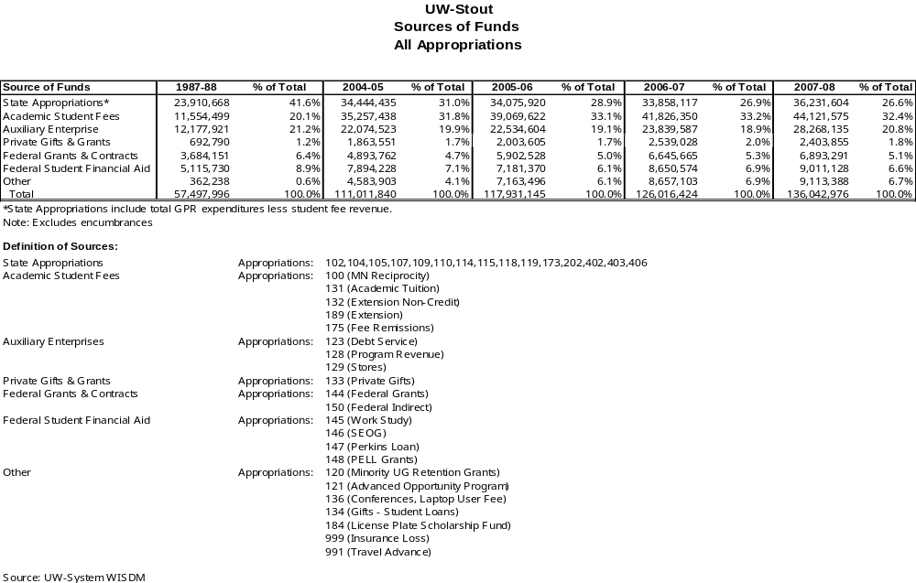

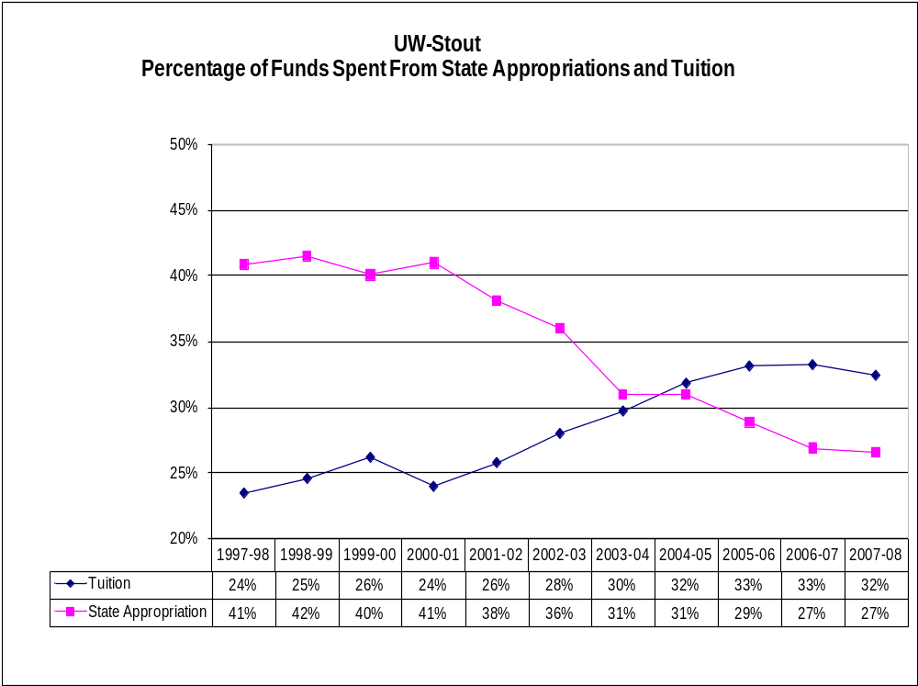

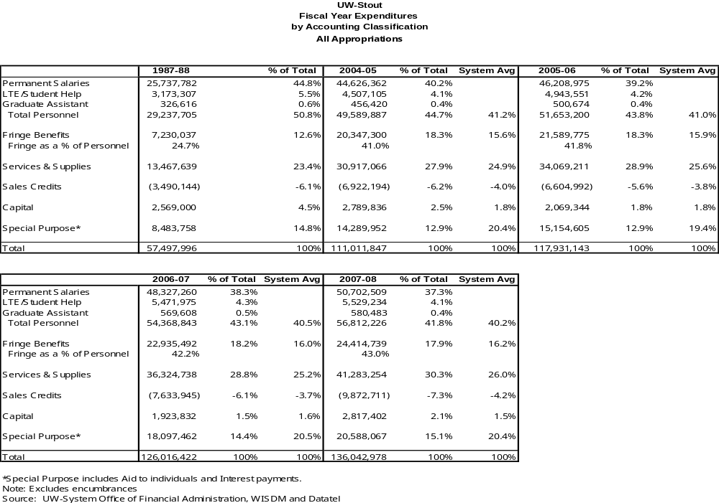

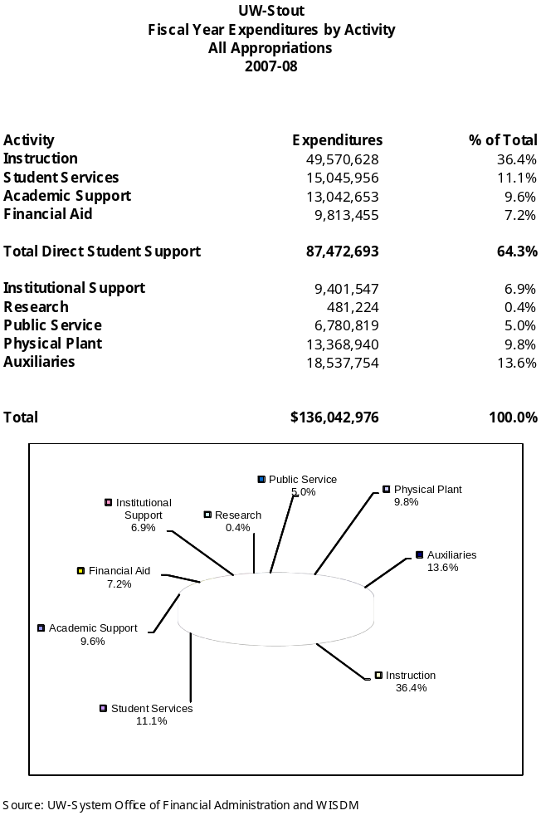

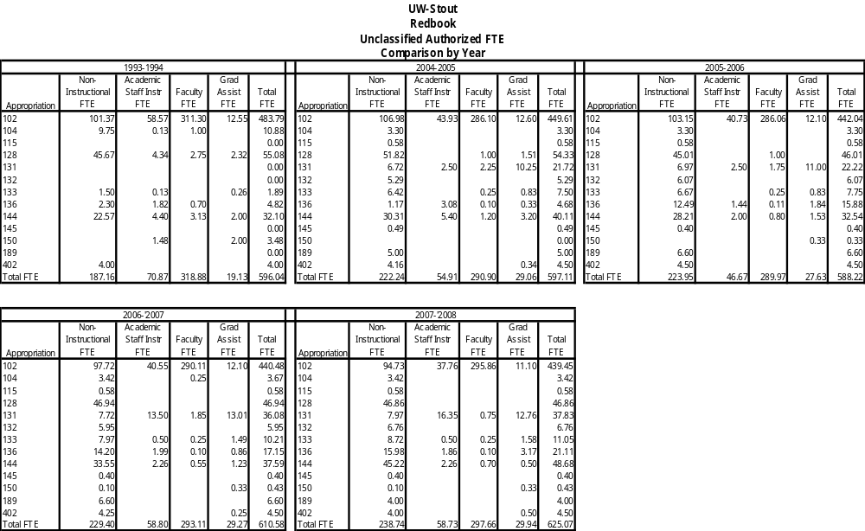

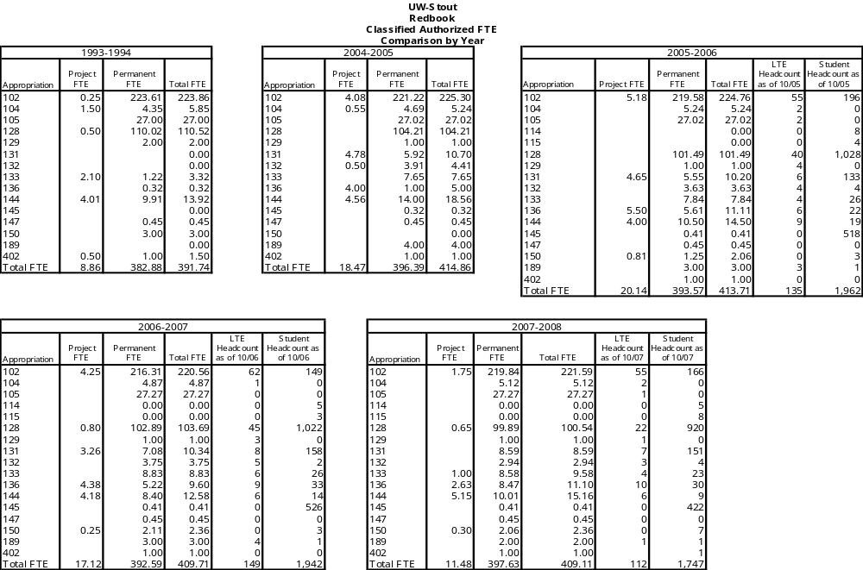

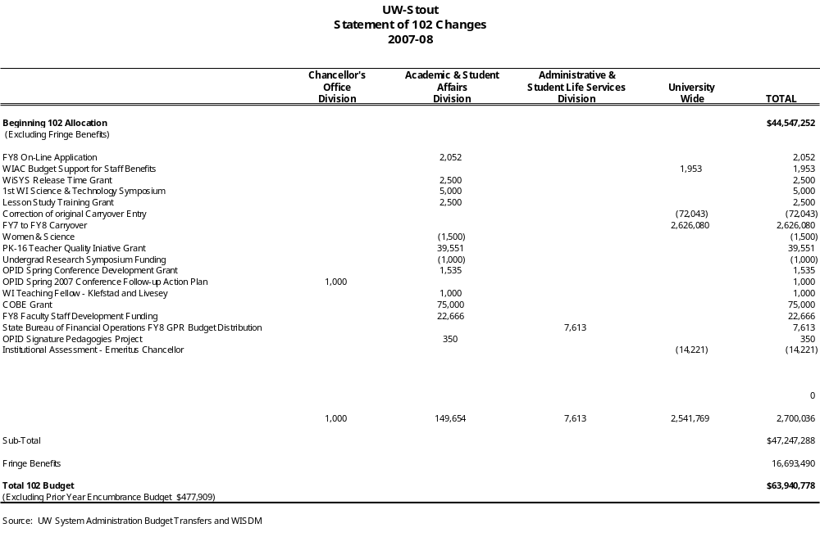

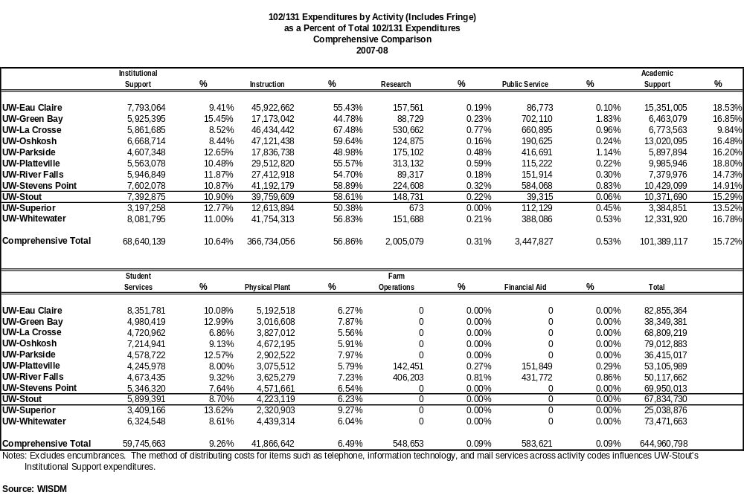

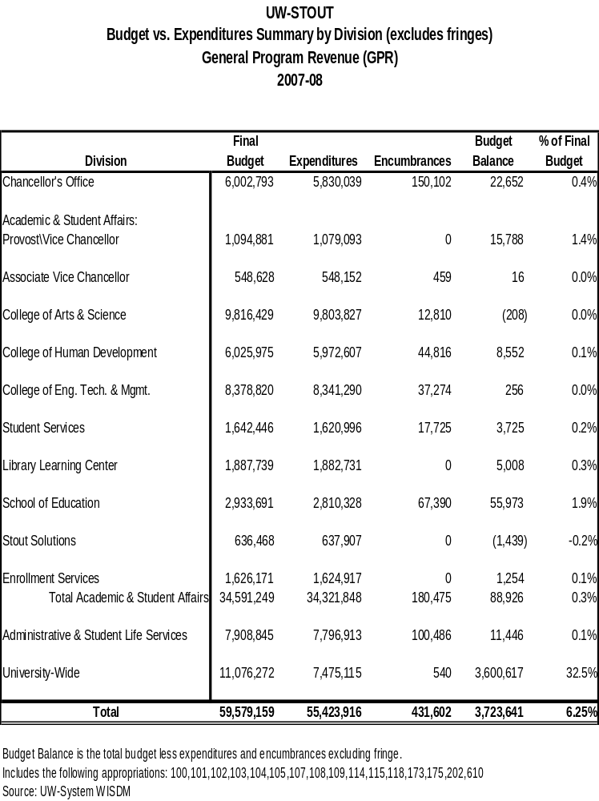

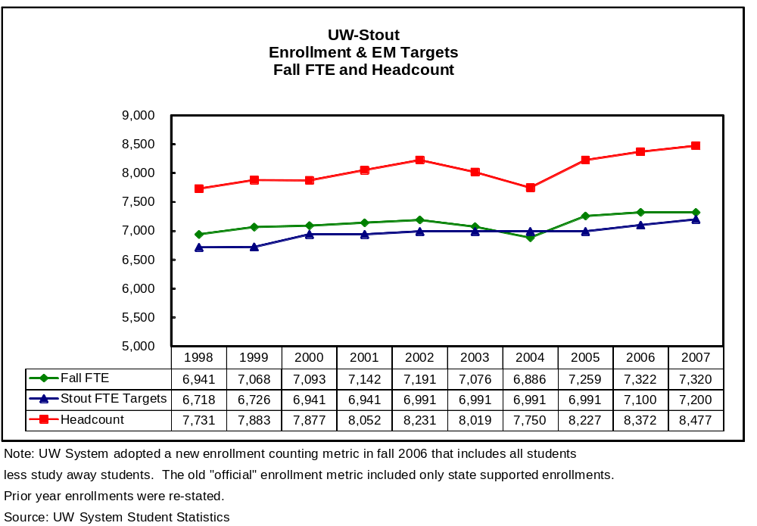

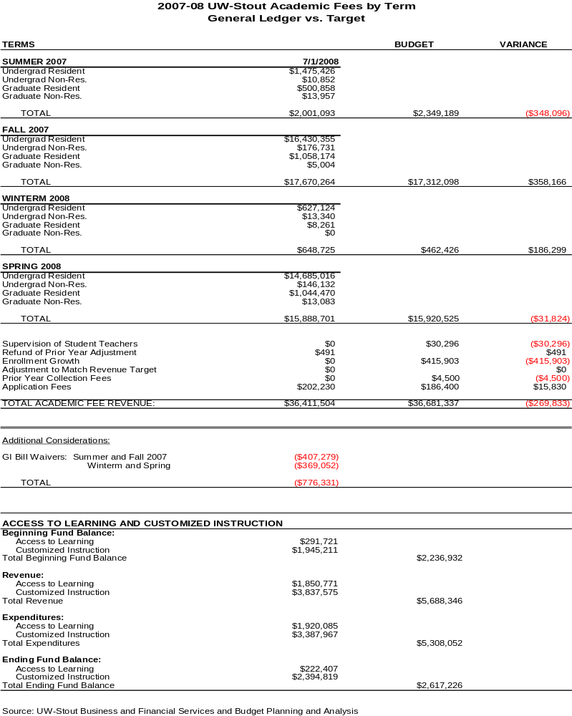
Student Technology Fee
2007-08

Total Funds Available |  |  | 716,503
Additional Funding |  |  | 28,913
2006-07 Carryover |  |  | 424,979
Potential Base Allocations:
Classified Support (Micheels Hall Lab Supv. Joe Conway) | Technology & Information Services | (65,448)
Classified Support (Tech Support Eliza Greer) | Technology & Information Services | (60,377)
Student Payroll (Micheels Hall Lab & Help Desk) | Technology & Information Services | (55,787)
SBC T-1 Service | Technology & Information Services | (6,240)
Telephone Line Rental (Micheels Hall Lab) | Technology & Information Services | (460)
Campus Network Upgrade | Technology & Information Services | (56,000)
Support Magic Help Desk Software | Technology & Information Services | -
Fringe Benefit (included in totals-see breakdown)
Fringe moved to SPF (already taken out of above #'s) | (36,974)
Total Base Allocations |  |  | (244,312)
One-Time Allocations:
Lynda.com Training (less returned funds) | Hunt/McIntosh | (72,003)
Student Network Access | Witucki | (7,852)
Google Search Appliance | Button | (25,963)
Computer Based Testing Center | Davis | (9,495)
LLC Scanner Request | Hagness | (3,297)
SSA Website Position | SSA | (4,150)
SPAM Software Maintenance | Wahl | (7,800)
Maintenance of KeyServer Client | Wahl | (20,460)
Learn at UW (D2L) | Wahl | (68,000)
Student SAN Data Storage | Wahl | (125,000)
Xythos License Maintenance | Wahl | (9,600)
Video Editing Stations (less returned funds) |  | -
Return unused funds from TIS |  | 42,632
Online Codes for Math/Statistics | Bendel | (197,454)
Outdoor Technology thru Stout Adventures | Mertz | (4,350)
Multicultural Office Computer Lab Upgrade | Scholfield | (10,658)
Rosetta Stone Project (less returned funds) | Smith | (19,090)
Library Learning Center Proxy Server | Lindahl | (8,047)
SLS Adobe CS3 Design Software | Nelson | (2,372)
SLS Student Involvement Even Awareness Software/Supplies | Shores | (12,045)
SLS Student Org Film Project | Shores | (11,078)
SLS Enhancing Student Network Access | Witucki | (8,457)
SLS Blue Devil Productions Server Acquisition | Ascher/Mueller | (4,938)
SLS Target Vision SDA Box/License Renewal | Castillo | (5,753)
SLS Energy Efficient LED & Portable lights | Castillo | (26,055)
SLS Great Hall Lighting Dimmer | Castillo | (25,000)
SLS Great Hall Sound Reinforcement | Castillo | (24,441)
SLS Portable Assisted Listening System | Castillo | (1,783)
SLS CKTO Basement Wireless Internet Access | Jenson/Griesbach | (2,848)
SLS PC24 port POE Switch to support wireless devices | Jenson/Karis | (2,848)
SLS return of unused funds |  | 16,197
Wireless Network Upgrade | Dodor/Wahl | (95,000)
Econ 210 Student Access Codes | Tyson | (10,000)
Total One-Time Allocations |  |  | (767,008)
Available Balance |  |  | 159,075

2007-08 Expenditure of Funds:
LIT
SPAM software maintenance $7,800
Maintenance of Keyserver clients in support of installed applications for laptop use – $14,706
Learn@UW (D2L course management system) - $54,720
SAN data storage supporting student data storage through BlueDrive - $123,105
Xythos license maintenance (BlueDrive software)- $8,471
Wireless Network upgrade; purchase controllers etc to enable dynamic load balancing of wireless access points - $94,502
Google Search Appliance - $25,963

Stout Adventures
Of the $4,350 awarded, $4,318.55 was spent.
1 ARC Microflix 406 PLB with GPS $650
2 Garmin nuvi 250 Widescreen $349.90
2 Garmin rino 530HCx GPS Two Way Radio $999.90
1 Garmin Topo United States 2008 100K DVD $100
4 Garmin ETREX VISTA GPS SYSTEMS $777.52
4 Vista cigarette lighter adapter $114.96
1 CITY NAVIGATOR NORTH AMERICA dvd $126.24
1 GPS made easy 4th ed. $11.96
4 DRY PACK CELL PHONE CASES $39.92
2 Rino Cigarette lighter adapter $57.48
1 SOLARPORT 4.4 W/BAT CHARGER $108.75
2 Garmin FORERUNNER 305 $546.26
2 SPEED CADENCE SENSOR $86.26
Total = $4318.55

Mathematics, Statistics and Computer Science

Access codes for online homework systems - $197,454

Multicultural Student Services
Expended all $10,658 for new computers (1 Apple, 6 HPs), HP printer and maintenance contract, scanner, add additional network ports, and required electrical work to upgrade computer lab in MSS office.

Art & Design
Lynda.com
- Tutorial licenses on 79 titles – $69,930
- Printing marketing materials: posters, mousepads, cards – $1,937
- Student employee wages – $113

International Education-Rosetta Stone Project
Total expenses: $19,090
- 22 floating client editions
- 1 Turkish 1
- 1 Spanish 1
- 1 Spanish 2
- 1 Italian 1
- 1 Italian 2
- 1 Japanese 1
- 1 Japanese 2
- 1 Dutch 1
- 1 Dutch 2
- 1 Swedish 1
- 1 Portuguese 1
- 1 Portuguese 2
- 1 Russian 1
- 1 Russian 2
- 1 Arabic 1
- 1 Arabic 2
- 1 Korean 1
- 1 Polish 1
- 1 Danish 1
- 1 German 1
- 1 German 2
- 1 Thai 1

Library Learning Center
- Expended $3,798.59 on new Xerox Documate 752 ($3,297.00 Student Tech fees, $501.59 University Library funds)
- Expended $9,018.00 on a new HP ProLiant ML370 G5 High Performance Server. ($8,047.00 Student Tech fees, $971.00 University Library funds)

Student Life Services

This report covers two allocations listed above. The allocations were part of a two phase project ($7,852+$8,457=$16,309). The Tech Fee Proposals were titled Student Network Access and Enhancing Student Network Access.

The funds were used to purchase:
5 computer kiosks stations (2350each) for $11,750
5 computers ($721 each) for $3,605
5 monitors ($194.65 each) for $973.25

The total spent on the project was $16,328.25.
This amount was $19.25 more than the allocation and it was covered by departmental funds.

- The LED lights and Intelligent Lighting project was funded in the fall of 2007. The equipment was purchased and delivered by April of 2008. Due to a newer LED lighting fixture release to the market after the proposal was submitted, 7 lights at a lower cost were purchased instead of the original 4 requested.
- The Great Hall Lighting project was funded in the fall of 2007. The equipment was purchased by May 2008. The installation has been on hold until the campus electricians can schedule a block of time to complete the job. They are scheduled for Winter Term to finalize the project. It was approved to have $8000 carried forward.
- The Assisted Listening Sound project was funded in the fall of 2007. The equipment was purchased and delivered by February of 2008. The Event Services Staff trained on the equipment during the spring. We are now in compliance with ADA standards for the hearing impaired for events in the MSC and have posted that we carry them near the Great Hall.
- The Great Hall Sound project was funded in the fall of 2007. The equipment was purchased and installed by May of 2008. The Event Services Staff trained on the equipment during the spring and summer. Since that time the equipment has been used 20+ times for a variety of events. This semester alone, the system is scheduled to be used for 35 times for student relevant events.

Outcome / Impact Statements:

LIT
- Continue maintenance support for Xythos software and hardware to provide a better interface to their provided network storage.
- Network wireless controllers purchased to enable LWAPP on the campus wireless access points allowing dynamic load balancing for the wireless network.
- Maintenance for Keyserver client licensing enabling the use of high end software for all undergraduate students.
- Learn@UW used to provide access for all students to the UW System wide Desire2Learn course management software system.
- Continued support for D2L course management system.
- Continued support for anti-SPAM services.
- Provide localized search capabilities for searches internal to the Stout web site.

Stout Adventures
Since the purchase of this technology in spring 2008, Stout Adventures has rented GPS units 22 times to UW-Stout students free of charge. The Garmin Magellan vehicle units are the most popular followed by the Garmin eTrex handheld units. Furthermore, Stout Adventures has developed a GPS clinic curriculum and the first GPS clinic will be offered to the University community September 17th this year. The clinic’s intent is to further educate patrons on the use of GPS technology to encourage future rentals.
Stout Adventures has also run a variety of trips for students and incoming freshmen since the purchase of this technology. The Personal Locator Beacon purchased with the grant money has accompanied every trip and its presence on future trip will ensure immediate medical response in the event of an emergency. Both participants and parents of participants are at ease knowing this technology exists on all Stout Adventures trips. Finally, Stout Adventures offered a youth summer outdoor program for Menomonie area youth in grades 3-8 this summer. The GPS units were used to teach Geocaching, a new sport young children and their families are finding very popular.

Mathematics, Statistics and Computer Science
The Math Teaching and Learning Center was created in the Fall of 2004 in an effort to improve the success rates of students in MATH-010 Fundamentals of Algebra and MATH-110 Intermediate Algebra. This center serves a large number of students. For example, at the beginning of the Fall 2008 semester, 324 students were enrolled in MATH-110 and 252 students were enrolled in MATH-010. Since its inception, student performance has improved substantially, as has been documented by annual reports from the center. A key component of the MathTLC is the use of online software aligned with the textbook which allows students to homework, quizzes, and testing online. With the online homework system, instructors can assign the appropriate amount of homework for students to successfully practice and develop their skills, and have students get immediate feedback on problems. All sections of these courses are taught in the Math Teaching and Learning Center using the same format.

The success of the software in these courses has led instructors to use this is or similar software in all of our general education courses: MATH-118, MATH-120, MATH-121, MATH-123, MATH-153, MATH-154, and STAT-130. Note that all Stout students are currently required to meet a six credit Analytical Reasoning component as part of the General Education requirements. As such, nearly every Stout student takes at least one of these courses during their tenure at Stout. The student tech fee funds have allowed us to purchase access codes for use by all instructors who wish to make use of this software in these courses.

Multicultural Student Services
This allowed us to replace outdated lab equipment and have the most current technology available to our students to aid in their retention and help achieve graduation.

Art & Design
Lynda.com
- After the success of the 1-year pilot in 2006-07, 3-year licenses were purchased and the number of titles increased from 62 to 79
- Marketing posters, bookmarks, business cards, and mousepads, were developed, produced, and distributed around campus
- In the 2007-08 school year, 15,636 tutorial clips were viewed a total of 48,144 times
- Selected video titles were upgraded to correspond with new versions of the related software

International Education-Rosetta Stone Project
The Rosetta Stone software purchased in 2007-08 enhances the language software available to our students for AY 2008-09. The benefit to our students is the availability of a wide range of language software for independent learning that can benefit study abroad, international internship, international travel, and career preparation. Languages added this year are those requested by students in 2007-08, and are languages for countries where study abroad programming is planned. The software will continue to be key-served and available to all UW-Stout students through ASK 5000. Information on the availability and use of the software is posted on the OIE website, and disseminated with the fall student laptop rollout and training, international student orientation, and Daily E-Mail. The Office of International Education continues to promote the use of the software, and information was distributed at Freshman Orientation in June. Instructors of the Spanish and French classes have indicated that they were able to use the software with their courses in 2007-08, that they will continue to use the software in 2008-09, and that it is an effective tool for their students. Feedback from students who used the software for study abroad preparation was very positive in 2007-08. A tracking system to monitor use of the software has been in place since 2007-08. Reports are found at http://helpdesk.uwstout.edu/KeyServer/usage/rosetta.asp. According to ASK 5000, the summary of launches resets when the server is reset, but currently shows 7041 launches for all the languages.

Library Learning Center
- The Documate scanner has replaced outdated Interlibrary Loan equipment in order to provide students with electronic copies of articles and book chapters.
- Replaced an out of warranty Proxy Server which permits student access to library indexes and databases from outside the library. This technology supports ease of use and access to information in support of research and coursework.

Student Life Services
The email kiosk stations were delivered individually over the course of spring semester 2008. Four kiosk stations were installed in the Memorial Student Center over the months of March and April 2008. The fifth kiosk is scheduled to be installed in Price Commons. The fifth unit is being retrofitted to be more wheelchair accessible. If that pilot kiosk is successful, the remaining four kiosks will be retrofitted as well.

The four kiosks that have been installed in the Memorial Student Center have been warmly received by students, faculty/staff, and visitors. We have received numerous positive comments about the convenience, attractiveness, and coolness of the email kiosk stations. Students especially like the ability to quick check their email or look up other information on the web, if they don’t happen to have their laptop or if they don’t want to reach into their backpack and boot up their system. Visitors and conference guests are especially grateful for the availability of the kiosks.

The comments and personal observations have been backed up by usage data. Although the kiosks are relatively new to our building, we have been able to install usage logs on each machine and collected some early data over the summer and during the first month of the 2008 school year.

The kiosk located near the MSC Administration office averaged 54 uses per day in September 2008.
During the summer camp & conference season it averaged 24 uses per day.

The kiosk located near Ballroom C averaged 55 uses per day in September 2008.
During the summer camp & conference season it averaged 37 uses per day.

The kiosk located near the Cedarwood Room averaged 94 uses per day in September 2008.
During the summer camp & conference season it averaged 38 uses per day.

The kiosk located near the Pawn averaged 98 uses per day in September 2008.
During the summer camp & conference season it averaged 38 uses per day.

Combined the four kiosks were used 9307 times during the summer months and 9331 times during the month of September.

The usage logs indicate an even distribution of usage throughout the day and for the most part throughout the week.

- The Event Services Staff trained on the LED lights and Intelligent Lighting equipment during the spring and summer. Since that time the equipment has been numerous times for a variety of events.
Fashion without Fabric
Stout Student Apparel Fashion Show
Student Housing Awards Dinner
Wisconsin Science & Technology Symposium
Thursday Night Blue Devil Productions Concerts (Fall ’08)
Freshman Orientation
Backyard Bash

The total attendance at the eleven events above was approximately 4770. The number of students attending these events was approximately 4070 which is about 51% of the student body.

- The Great Hall Lighting project has the potential to affect a large part of the student body. It would enhance events like the MAE concert for homecoming, other concerts, or entertainers. These kind of events often pull about 400-600 attendees.
- The Assisted Listening Sound project directly affects students with hearing impairment so that they can participate at events.
- The sound system for the Great Hall has been requested 40 times this semester making 88% of events in the Great Hall that require the sound system for student relevant events.
2008-09 Objectives:

LIT
- Continue support of keyserve licensing and maintenance to provide access to high end software applications for students and faculty.
- Continue to support the maintenance for the anti-spam services provided to all students.
- Continue to support the Xythos (BlueDrive) software and hardware for student network storage.
- Look into more wireless network upgrades. The wireless network has improved much but more can be done to support the students network connectivity across campus.
- Continue support for D2L course management system.

Stout Adventures
Stout Adventures will continue to advertise the availability of this free rental GPS technology to the UW-Stout students. Currently the Stout Adventures website and the Stout Adventurer newspaper highlight the availability of these GPS units. It is our hope that more and more students use these resources.
Additionally, Stout Adventures will continue to offer and develop clinic curriculum for the university community to engage in and learn from.

Mathematics, Statistics and Computer Science
Purchase sufficient access codes for students to use online homework systems in MATH-010, MATH-110, MATH-118, MATH-120, MATH-121, MATH-123, MATH-153, MATH-154, and STAT-130 if used by the instructor.

Multicultural Student Services
- Assist Advisors in monitoring office/computer lab usage via Advisortrac (advising software)

- Provide student population alternate access to technology between classes.

- Provide computer access to graduate student population (not part of laptop program).

- Provide convenient hours along with access to other resources in Student Services area.

Art & Design

Lynda.com
- Continue to update titles as software upgrades are released and implemented by Stout. Updates are included in licensing fee.

International Education-Rosetta Stone Project

In 2008-09, the Rosetta Stone Project will:
- Increase the number and variety of Rosetta Stone languages available through the Student Tech Fee sponsored program. The languages funded previously are: English, French, Spanish, and Mandarin Chinese.
- Provide access for language study in English at 3 levels for any student, but particularly those whose primary language is not English.
- Promote use of the English language software for international students at UW-Stout through individual advising of international students and OIE sponsored programming such as “English Conversation Hour” and the International Relations Club.
- Provide all students access to language learning for Arabic, Chinese (Mandarin), Danish, English, German, French, Italian, Japanese, Portuguese, Russian, Spanish (Central America), Spanish, Thai, Turkish.
- Promote use of Rosetta Stone Software for pre-departure preparation for study abroad students.
- Evaluation of the project in 2008-09 will be done using the data tracking for client use and evaluations of on-campus and study abroad programs offered through OIE, and solicited feedback from language instructors on campus.

Library Learning Center
Replace out of warranty desktop computers to support student coursework and research with the most current technology. Although undergraduates are issued laptop computers, many students use the desktop computers in the library for a variety of reasons: laptops are heavy and some days students choose not to carry their laptops to campus; students want to save their battery power for class or lab; students find for longer projects it is more comfortable to work at a desktop than their laptops.

Student Life Services
During the 2008-09 school year there are a few objectives regarding the public access computer kiosk stations. First, to complete the wheelchair access retrofit on the fifth kiosk and install it in Price Commons. Second, to evaluate the wheelchair access retrofit and if successful, apply it to the four kiosks in the MSC. Third, to program the entry screen of each kiosk to include a web link called “Today in the MSC (or Price Commons)” That web link would automatically take the user to the Virtual EMS (event management software) page showing the days meetings and events in the given building. It would be another small but convenient service for students and visitors alike. Fourth, to program an additional BigBox DVD button on the entry screen of the kiosk located by the Pawn. This kiosk sits directly across from the new BigBox DVD kiosk. The kiosk button can be programmed to go to the BigBox DVD site and in effect allow the user to see what is in the BigBox DVD kiosk if another user is busy at that station. Lastly, we will continue to collect monthly usage logs to evaluate the overall success of the program.

- Energy Efficient LED & Portable Lights - In the end, the aesthetic quality that was added to events mention above created an overall enjoyable and professional experience for those attending, but especially for those hosting the event. In addition, the LED lights use 77% less energy than traditional lights, give off 80% less heat, and have a life span that is 38,000 hours more than traditional lights. They also produce 4.2 billion color combinations. For environmentally conscious students, the advantage is a big step towards producing a “green” event.

- The Great Hall Lighting project bring a better, efficient means of running lights in the Great Hall. It would also allow for the integration of our recently purchased LEDs and intelligent lights, again, enhancing the aesthetics of events in the Great Hall that students attend or host.

- The Assisted Listening Sound project is in compliance with ADA standards is meant to ensure equal participation at events so that all students experience those events as a community.

- The Great Hall Sound project is for students who attend events or host events in the Great Hall that require sound reinforcement, the new system adds the quality and professionalism of the event.

University of Wisconsin-Stout
2007-08 Annual Teaching Workload Report Executive Summary

Introduction
Faculty workload issues emerged as one of the top priorities of the university during the facilitated group sessions commencing the 1996-97 budget process. Over the past decade, the university engaged in several strategies including this report to address workload issues.

Purpose
This report will summarize annual workload information for faculty/staff by college. Information gathered includes,
(1) assigned time, (2) overload payments, (3) instructional workload measures generated from UW System PMIS and IAIS reports and (4) workload perception.

Summary of Results
- Total assigned time for 2007-08 was 33.08 FTE. This number represents 8.7% (9.3% in 2006-07) of the total FTE instructional positions at UW-Stout. Assigned time includes positions such as Director of Bands, Honors Program Director and Senate of Academic Staff Chair, to name a few.

- Overload payments (including winter session) increased from 2006-07 to 2007-08 by 11%, or nearly $109,000. Overloads for 2007-08 came to a total of $1,118,240, which is the highest total over the past six years.

- The 2007 UCLA HERI Faculty Survey question on teaching load show that satisfaction has increased slightly for full-time undergraduate Stout faculty/staff from 2004. In 2004, 34.4% (44.9% in 2001) indicated that teaching load was satisfactory or very satisfactory, whereas, 36.6% did in 2007. Stout’s score is lower than both the Public 4-year Colleges (47.3%) and all 4-year Institutions (57.7%). Teaching load was also listed by 80.3 % (76.4% in 2004) of those responding as a source of stress; an increase of nearly 4 percentage points from 2004.

- UW-Stout remains below the comprehensive average by about 6.5% in both SCH/FTE and Student to Staff Ratio.
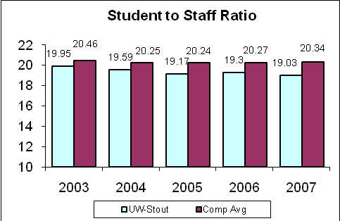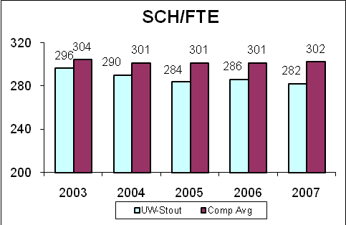
Source: IAIS, Cost per Credit, Total Instructional Budget Source: IAIS, Cost per Credit, Total Instructional Budget
- Weekly Group Contact Hours increased slightly along with Average Group Course Credits. Average Group Course Credits for Stout is at 11.1 compared to the comprehensive average of 10.5.

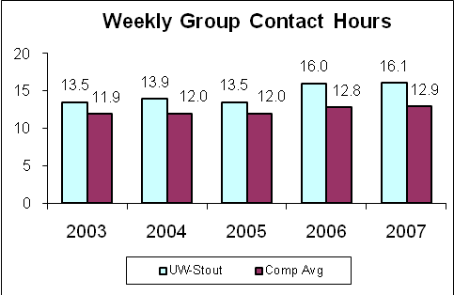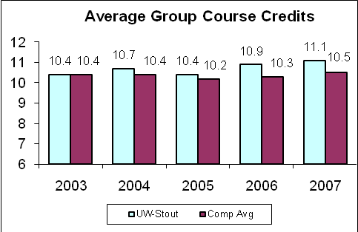
Source: IAIS, Faculty Contact Hours Source: IAIS, Curricular Analysis
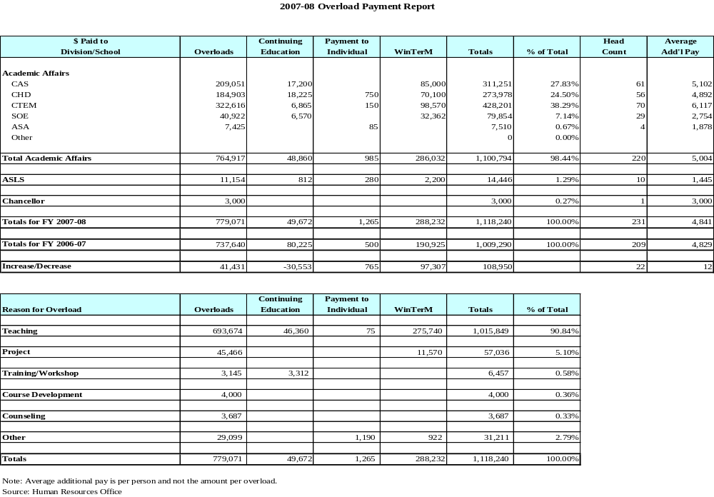
UW-Stout
Computer Cost Share Program

The computer cost-share program was designed to share 50% of the cost of new and replacement computers, including the cost of maintenance, network connection and Microsoft Office Pro software. The program, which was started in 1995-96, was modified in 2000-01 to support the campus movement to a laptop environment. Desktop computers continue to be supported at 50%, up to $1,550, for employees who perform the majority of work at their workstation. Laptop computers are supported at 50% up to $2,150, for faculty and instructional staff, as well as other interested employees.

Beginning in 2001-02, Compaq was awarded the contract for all PC’s. Apple is the laptop provider for academic programs in Graphic Communication Management, Art, and Art Education.

The program runs continuously throughout the fiscal year and is designed to purchase computers for faculty, academic staff and classified staff funded from 102 departmental accounts and the 131 enrollment growth account. However, 102, 128, 150 or 151 accounts may be used to cover the department's share of the cost. A Cost Share Computer Purchase Form must be completed to participate in the program.

During the past year, 245 computers (185 laptops and 60 desktops) for faculty, academic staff and classified staff were purchased at a total cost of $509,974. Since the program was started in 1995-96, 2,547 computers have been purchased at a total cost of $6,733,231.

Year | Dollar  Amount | Number of  Computers | Laptop | Desktop | Apple | Compaq
1995-1996 | $601,611 | 227
1996-1997 | $379,457 | 136
1997-1998 | $328,460 | 142
1998-1999 | $493,064 | 210
1999-2000 | $472,333 | 188
2000-2001 | $607,147 | 200
2001-2002 | $727,475 | 236 | 172 | 64 | 35 | 201
2002-2003 | $529,762 | 197 | 140 | 57 | 20 | 177
2003-2004 | $547,035 | 204 | 135 | 69 | 28 | 176
2004-2005 | $585,819 | 193 | 149 | 44 | 19 | 174
2005-2006 | $479,927 | 189 | 152 | 37 | 15 | 174
2006-2007 | $471,167 | 180 | 137 | 43 | 29 | 151
2007-2008 | $509,974 | 245 | 185 | 60 | 22 | 223
In 2002-2003 one Dell computer was purchased as an exception.

UW-STOUT
CAPITAL PROJECTS

The first year of the 2007-09 biennium resulted in the approval and construction of the following capital projects and planning studies:

Construction of the Jarvis Hall Science Wing Renovation and Addition project began in June 2008. Project completion is scheduled for August 2010.

Major project documents submitted for the 2007-2009 Capital Budget include: Harvey Hall Renovation-Phase I Theatre (approved at $5.139 million); Merle M. Price Commons Second Floor Renovation (approved at $3.975 million); and the Hovlid Hall Renovation and Addition (approved at $12.4 million). The Bowman Hall Admissions/Welcome/Information Center was approved as an All Agency project at $614,500.

The 2009-2015 Campus Physical Development Plan was completed and submitted to UW System Capital Planning and Budget. The highest priority issue for the campus is a major remodel of Harvey Hall. Paramount to the continued use and functionality of Harvey Hall is the upgrading of the building infrastructure (life safety, ADA accessibility, electrical, HVAC, plumbing and telecommunications). The inability to receive funding for the renovation has been a disappointment. Other priorities include: Changing Programs and Infrastructure Upgrade – Home Economics Building; Changing Needs in Student Services Areas – Bowman Hall; Growing and Changing Programs in Communication Technologies Building; Residence Hall Infrastructure and Ability of Aging Residence Halls to Remain Competitive, University Centers, Appropriate Facilities and Location for Student Health Services, Robert S. Swanson Learning Center and Campus Parking. In addition, six continuing themes have been identified: Classroom Size, Quality and Adequacy; Infrastructure Concerns Related to Older Buildings; The Right Space: Consolidation of Similar Functions, and Availability to the Public and Telecommunications Closets, Life Safety and Accessibility, Sustainability and Wiring Needs.

The Request for Pre-Planning Architectural Services was approved for the University Centers Renovation project. It is anticipated that planning and construction authority will be included in the 2009-2011 Capital Budget.

Nine (9) Laboratory Modification Project Requests for 2008-2009 were approved totaling $312,319. Projects include: Biotech Cell and Molecular Biology Lab, 215 Jarvis Hall Science Wing; Golf Enterprise Management Lab, 436 Home Economics; Psychology/Psychophysiological Lab, 158 Vocational Rehabilitation; Rendezvous Lab, 269 Home Economics; Food Production Lab, 304 Home Economics; Visual Resources Center, 323 Applied Arts; Early Childhood Education/Art Education, 103 Home Economics; Preschool Lab, Child and Family Study Center; and Generally Assigned Classrooms, Learning Technology Services.

Nine (9) Laboratory Modification Matching Funds Project Requests for 2008-2009 were approved totaling $218,364. Laboratories which received project funding include: rooms 8/14, 104, 112, 213 and 315 in Fryklund Hall; rooms 108 and 116 Communication Technologies; and room 221E in Applied Arts.

No E-Scholar Classroom Funds Project Requests were funded for 2008-2009.

Acquisition of properties around the campus also continues. Three (3) properties were acquired on North Campus: Cenex parking lot and two private residences. Discussions on five (5) other properties on North Campus continued. Twenty-five (25) Space Requests were approved at a total cost of $668,148.

Development of the Campus Master Plan continues with Miller Wagner Coenen/ McMahon as consultant.

A Laboratory Audit was completed with a Laboratory Renewal Plan to follow.

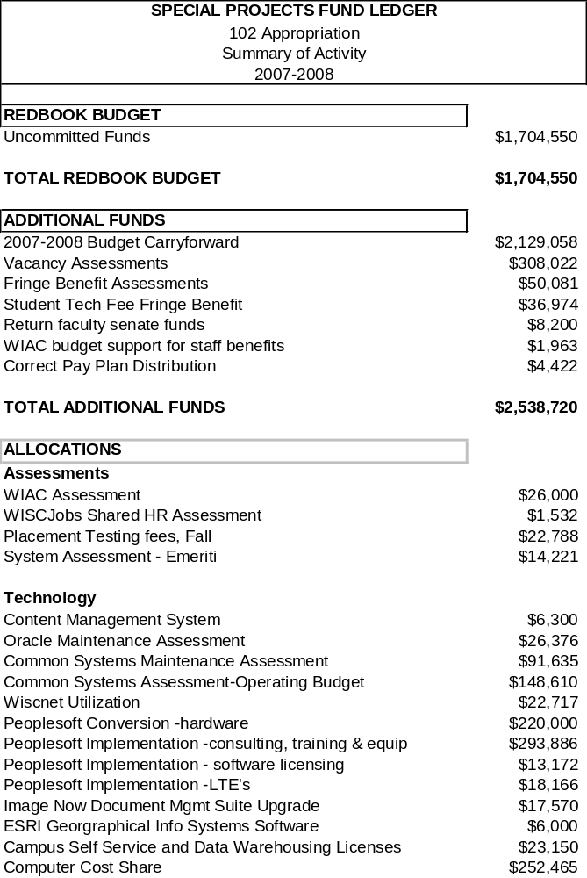



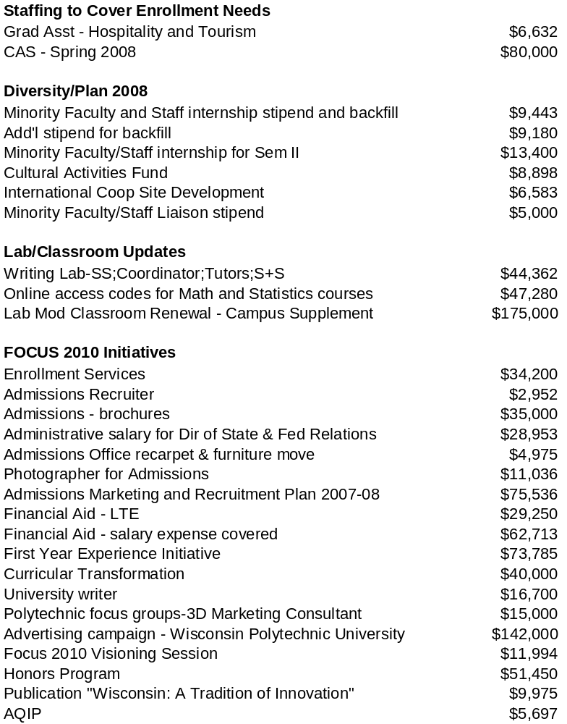

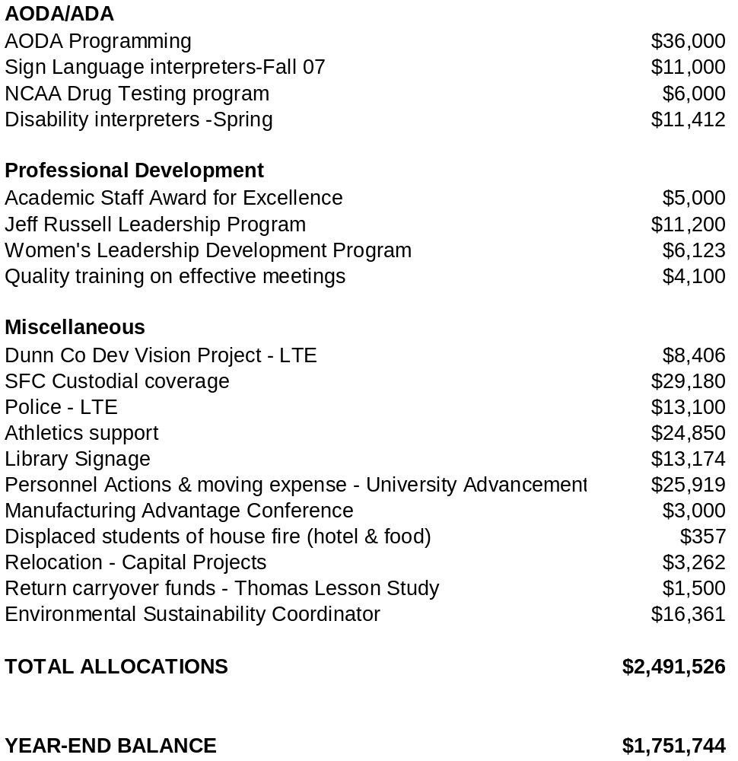

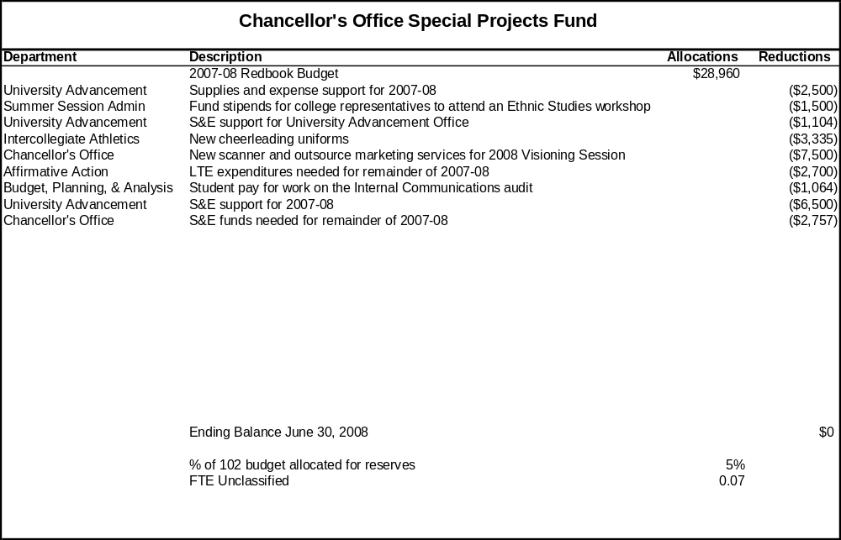

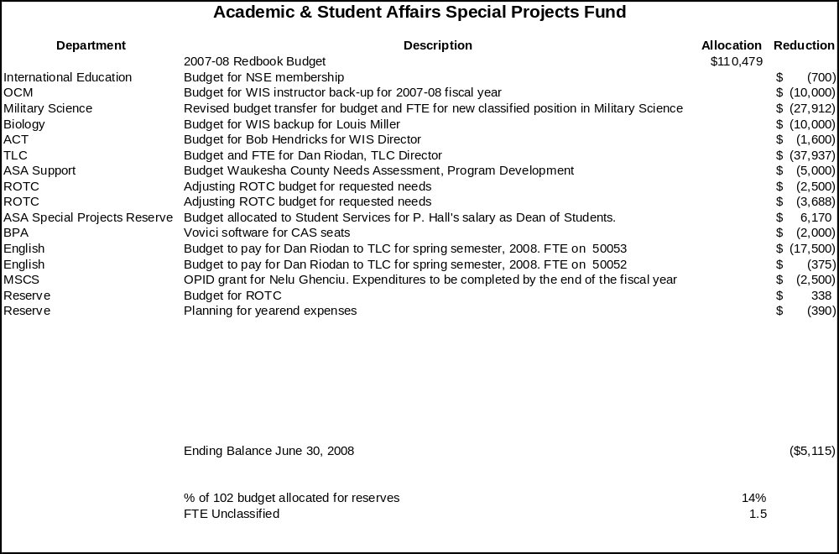

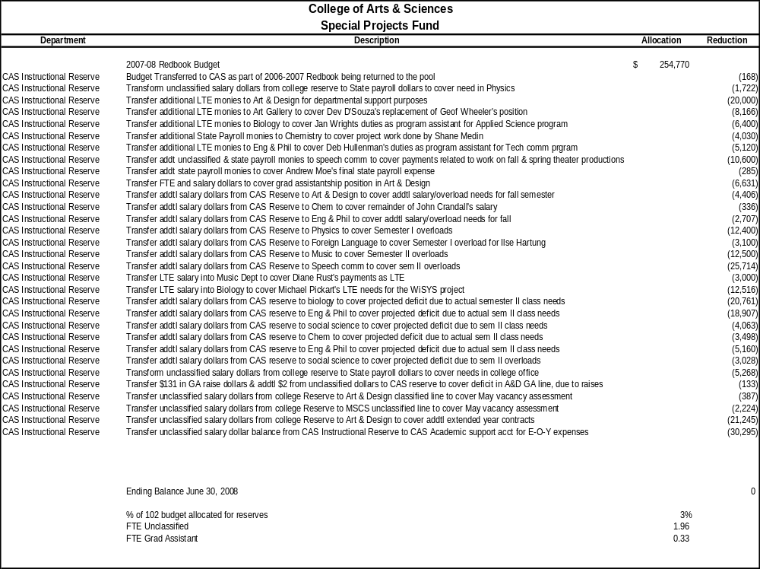

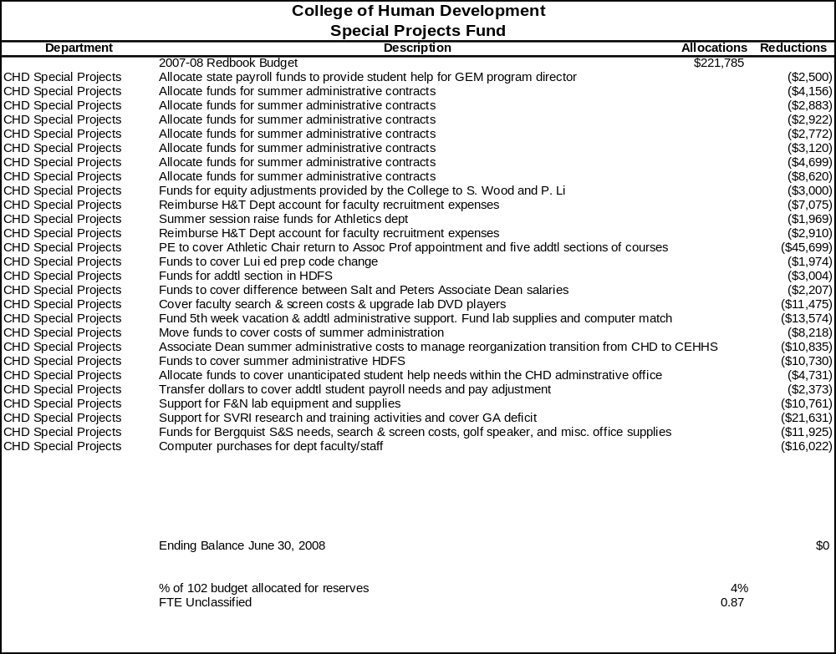

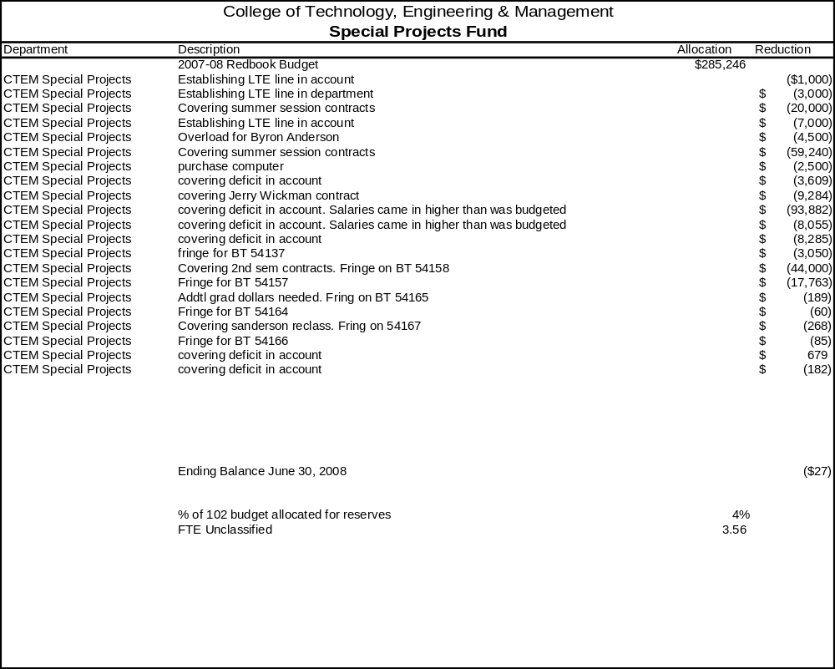

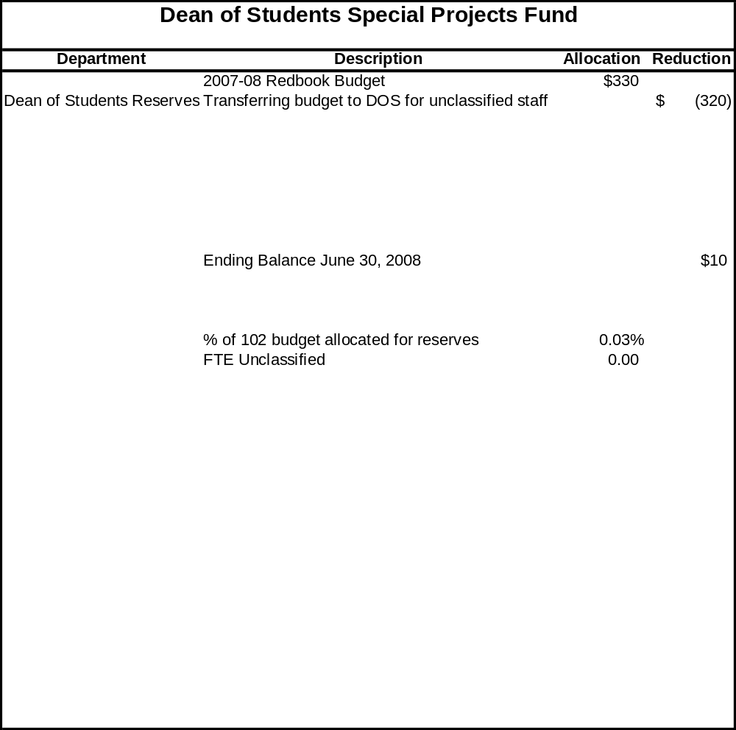

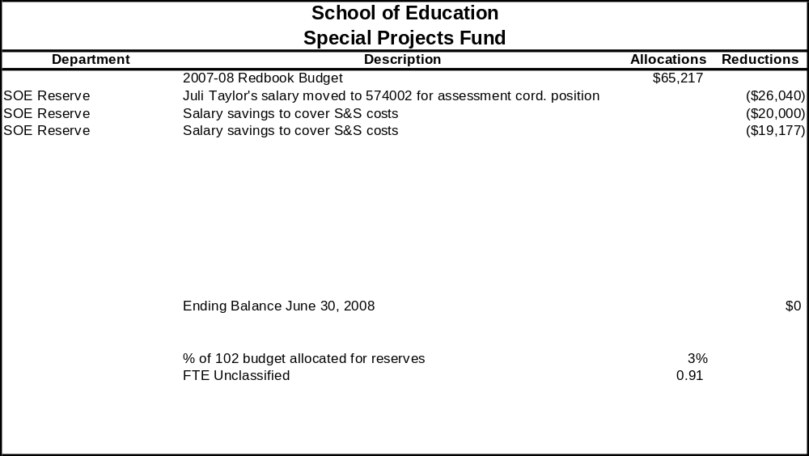

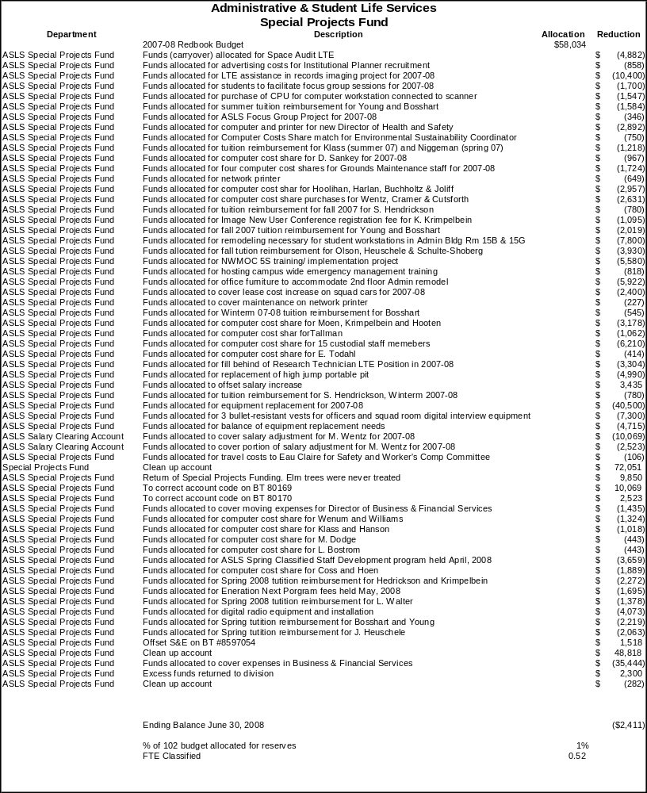

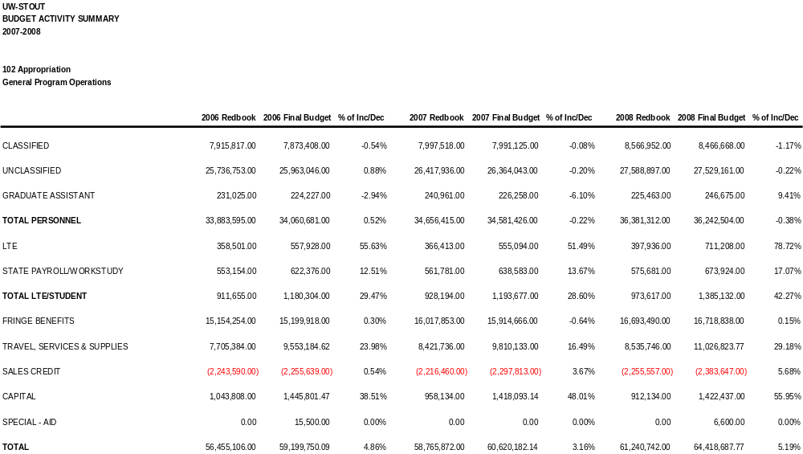

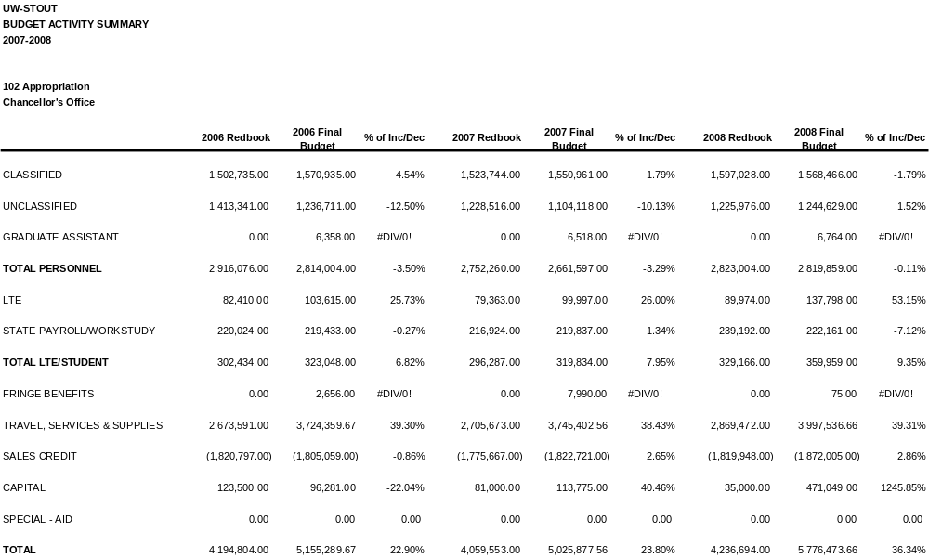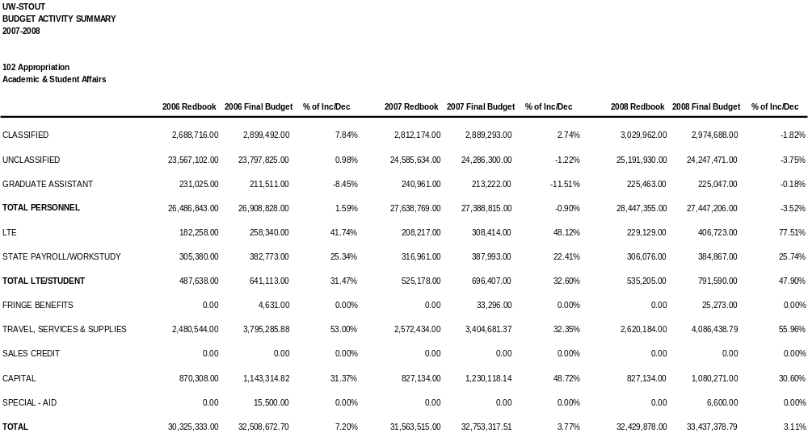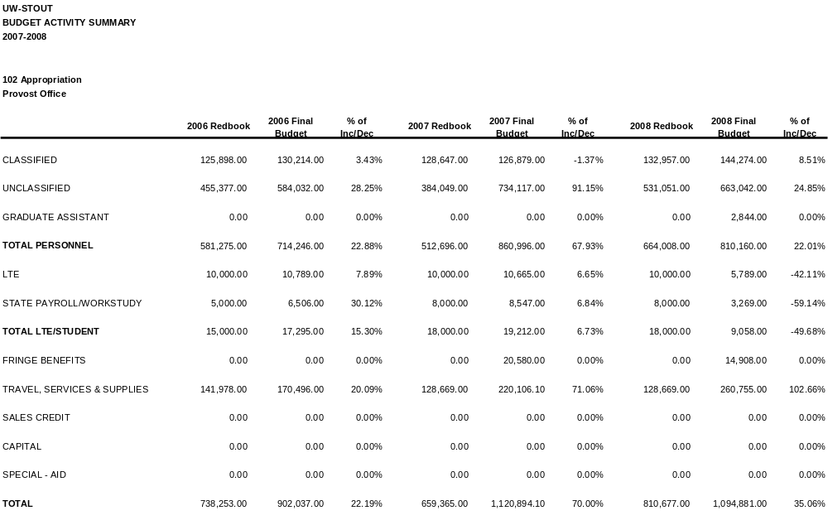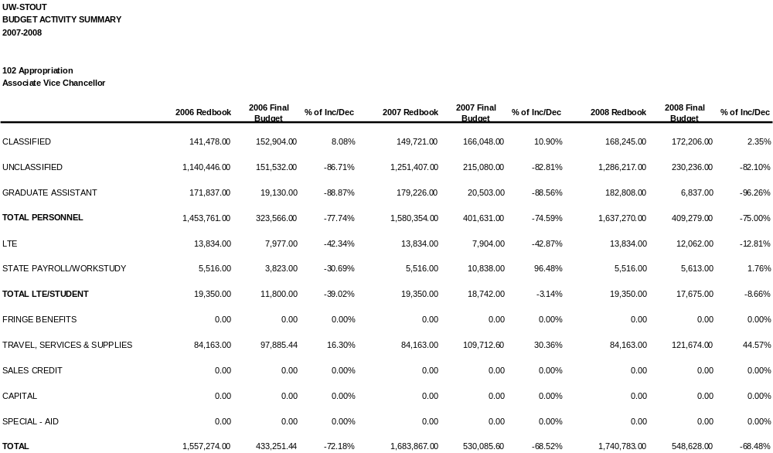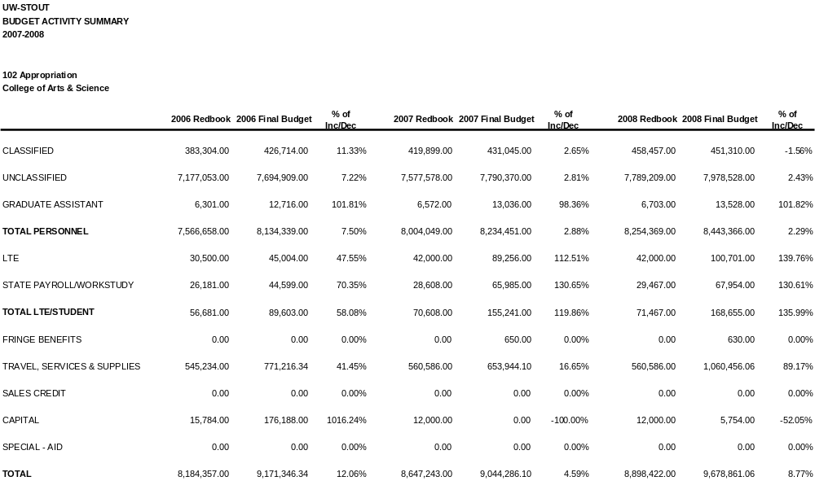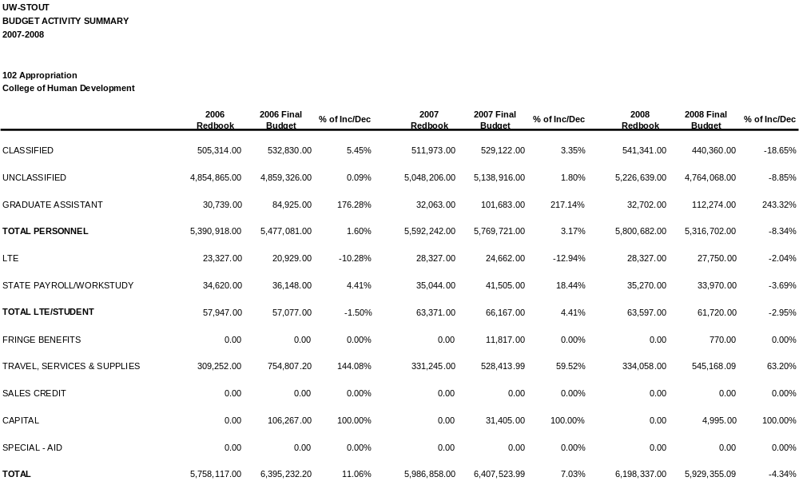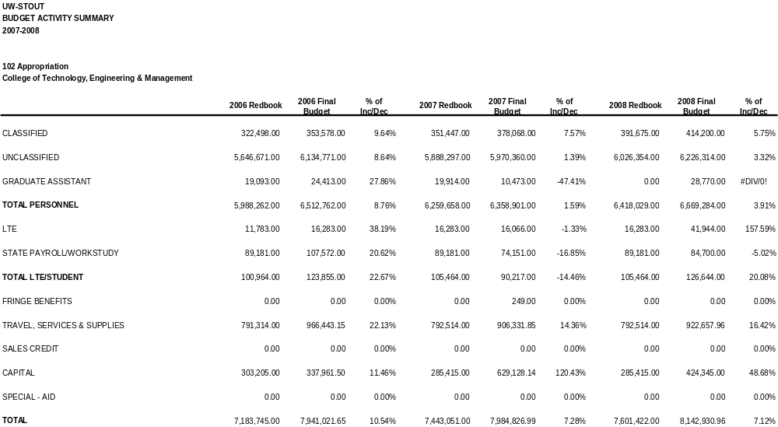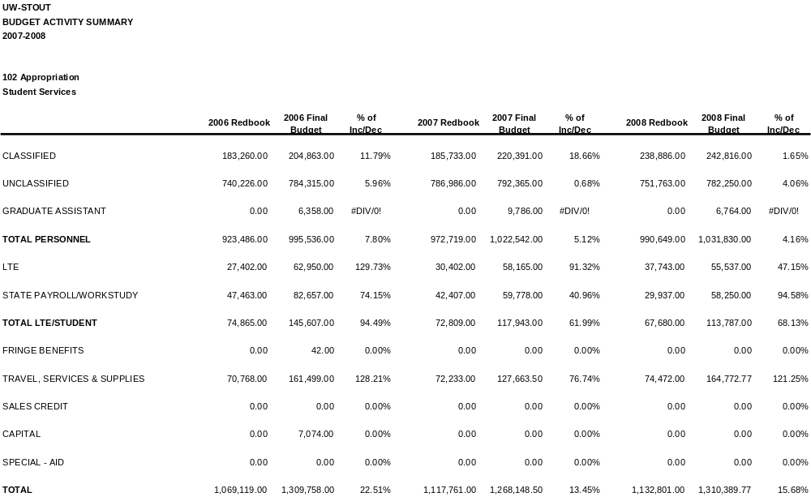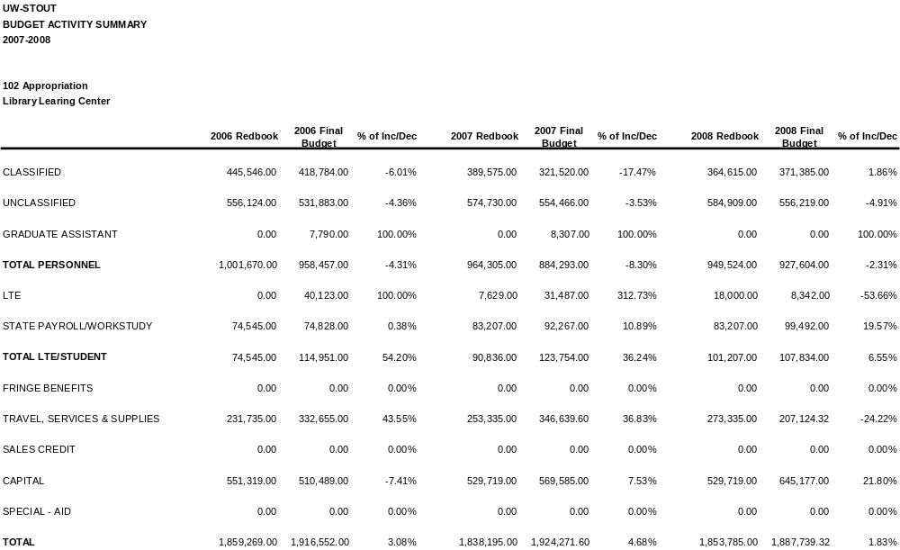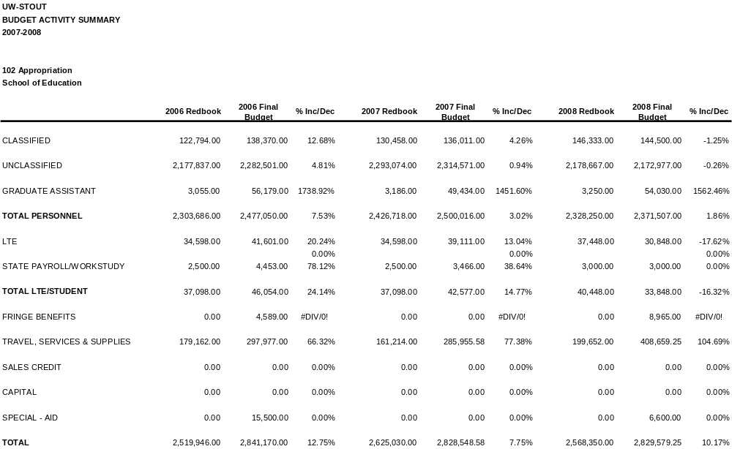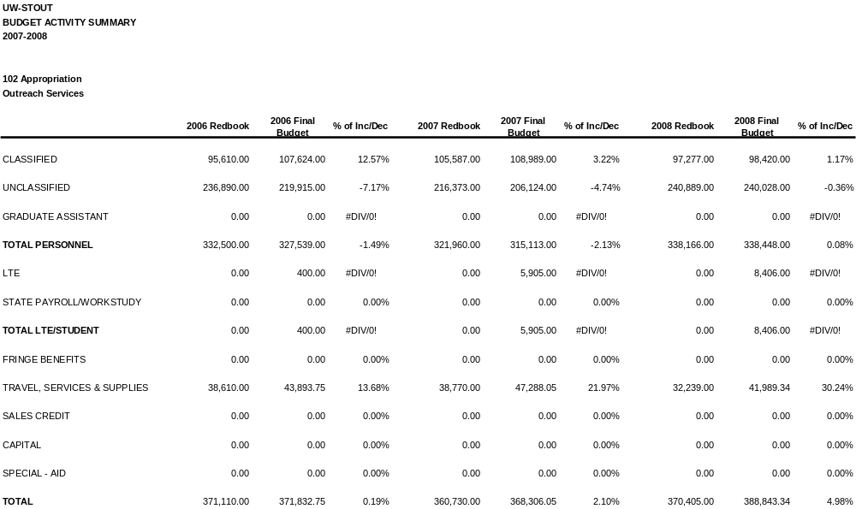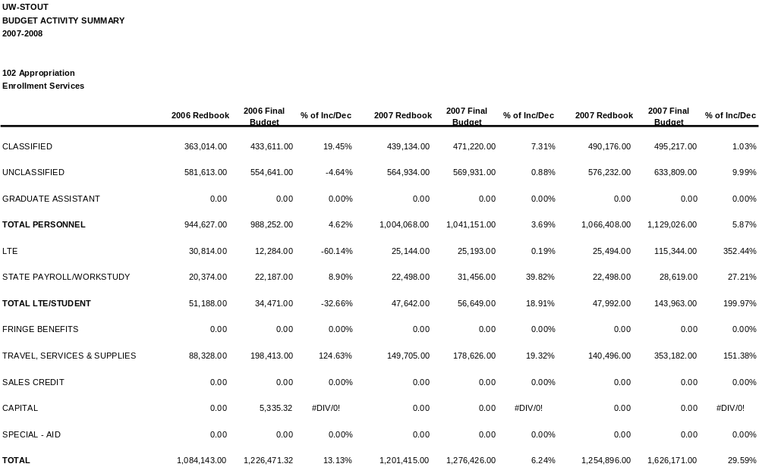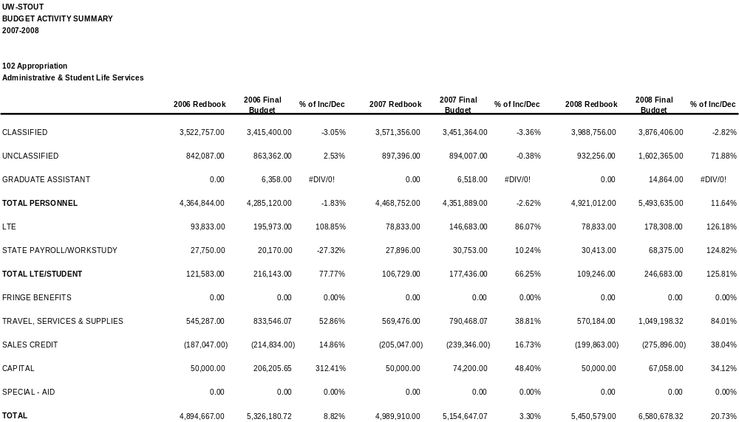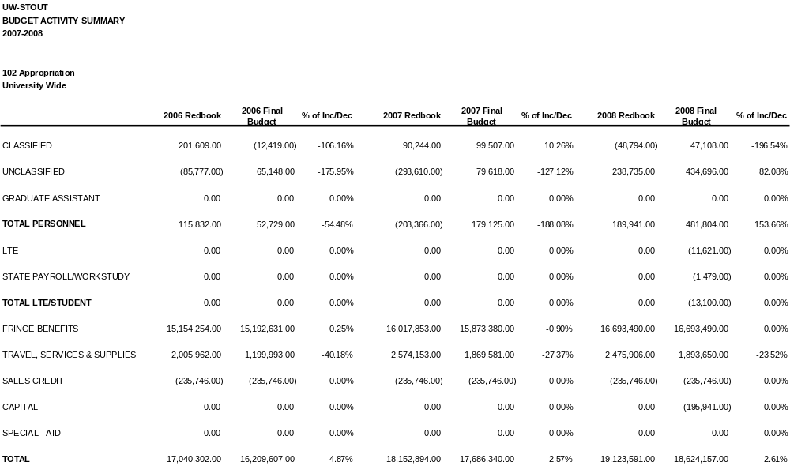

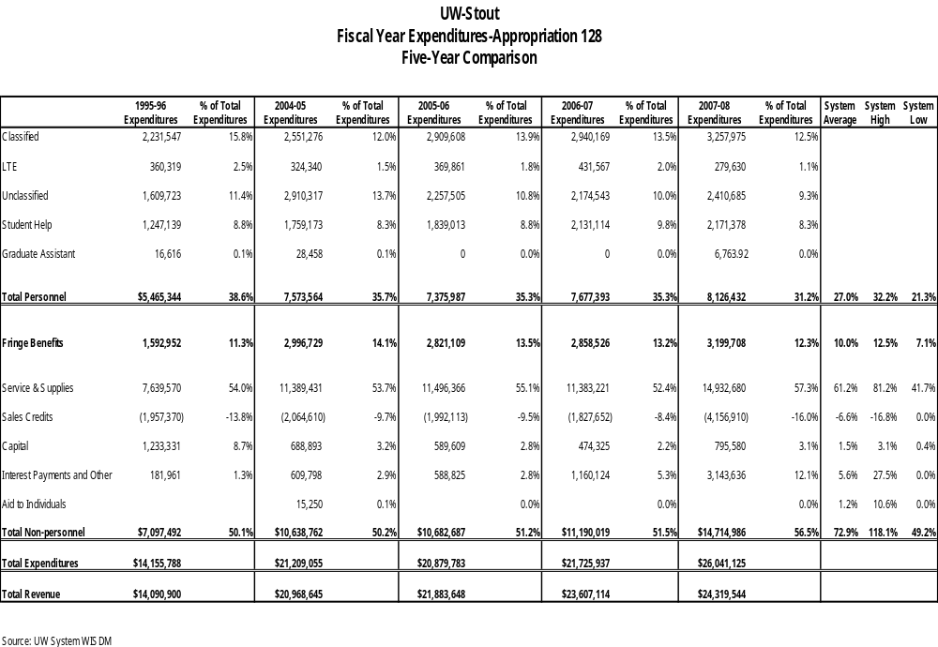

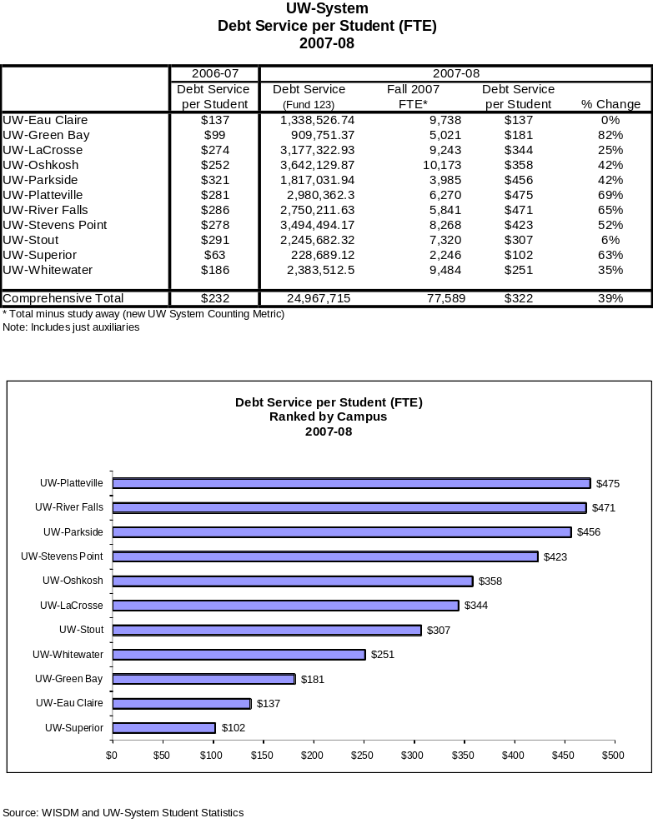

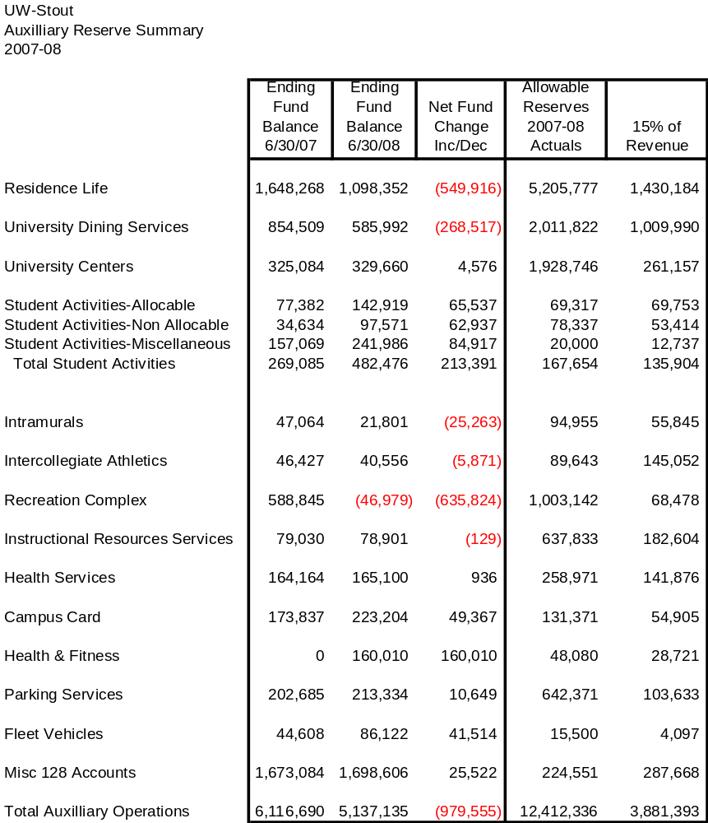

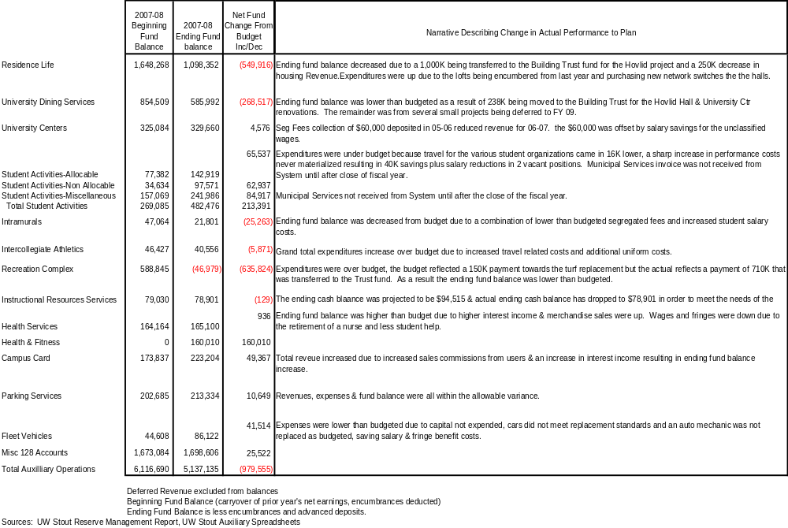

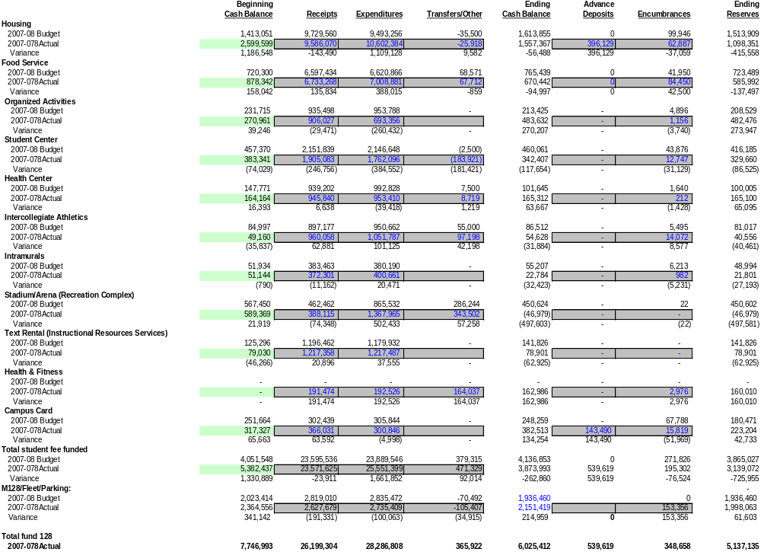

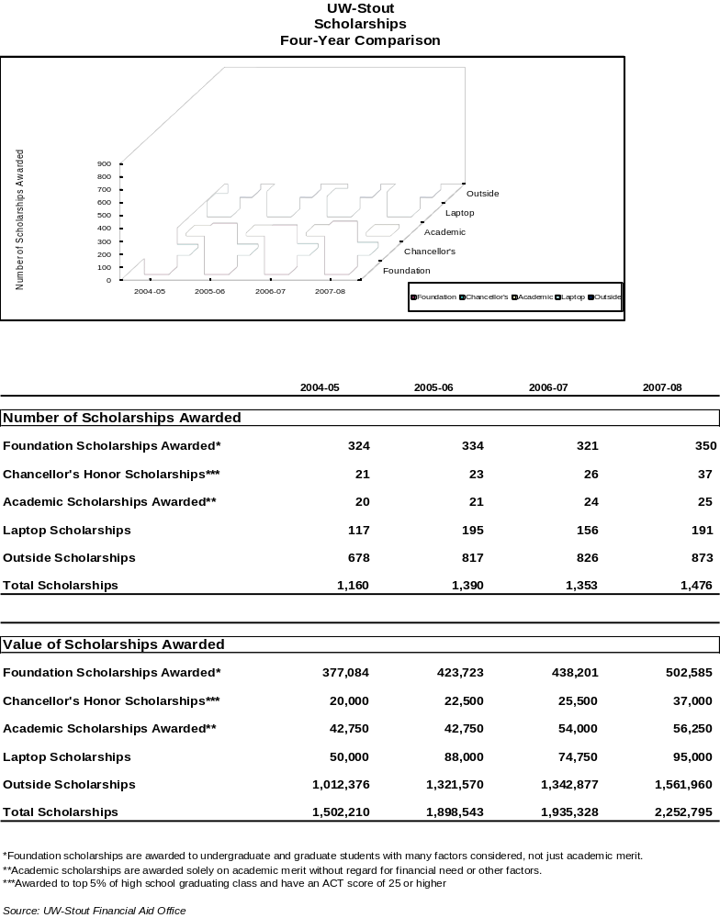

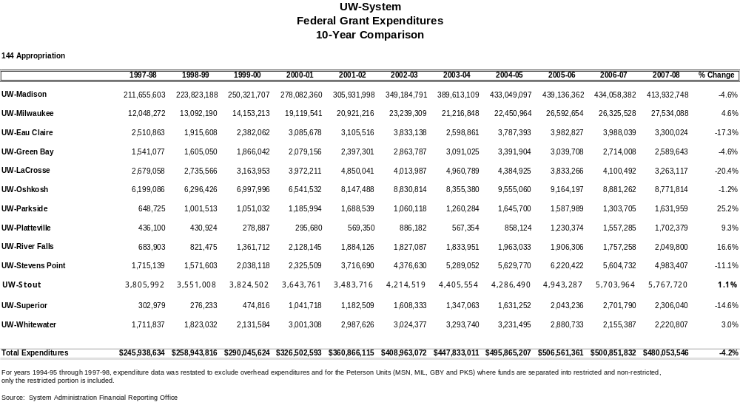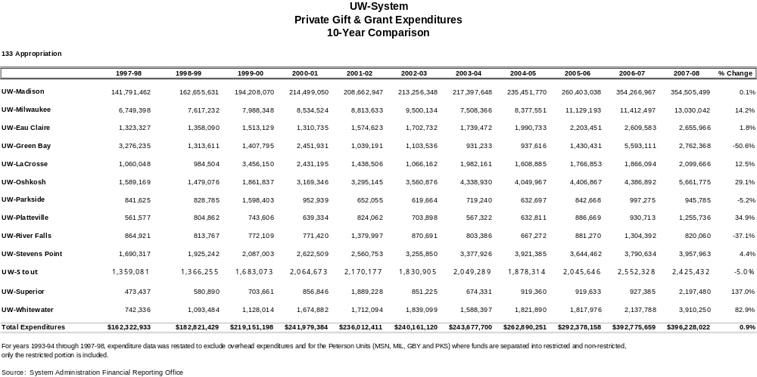

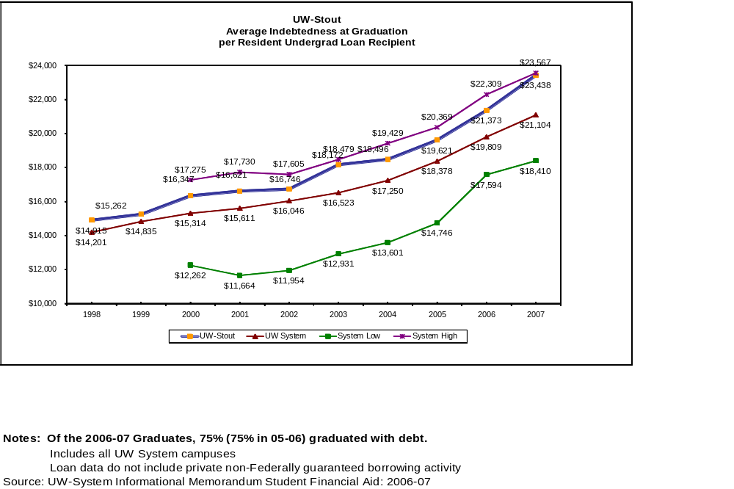

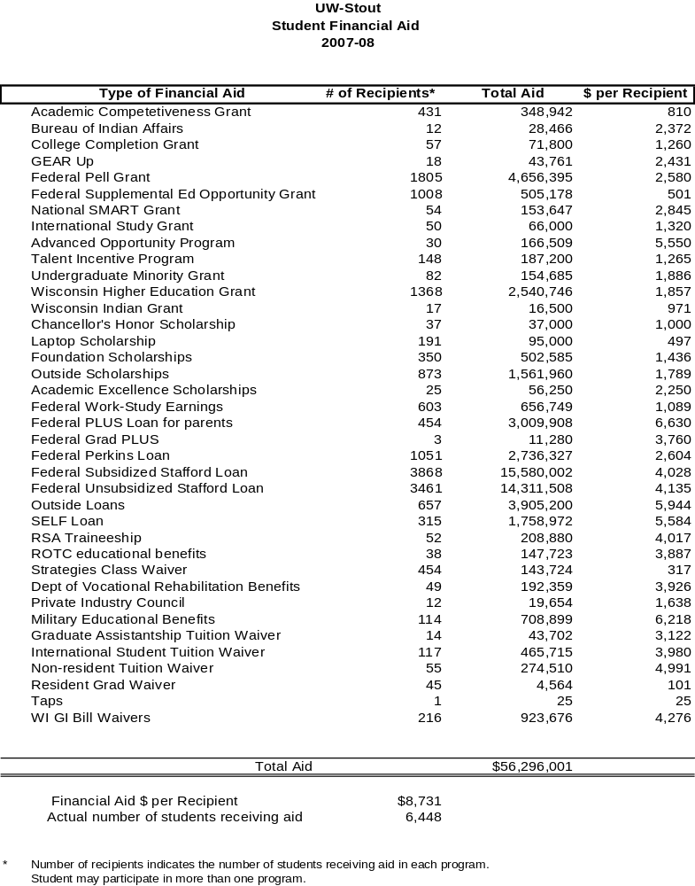
Cumulative Student Loan Debt for 2006-07
UW System Resident Undergraduates Completing a Bachelor’s Degree
by Institution

 | Loan Recipients | % Grads with Loan Debt | Average Debt
UW-Madison | 2,393 | 57% | $21,092
UW-Milwaukee | 2,331 | 70% | $23,567
UW-Eau Claire | 980 | 67% | $19,641
UW-Green Bay | 665 | 70% | $18,840
UW-La Crosse | 832 | 65% | $19,540
UW-Oshkosh | 1,182 | 71% | $22,738
UW-Parkside | 350 | 67% | $20,367
UW-Platteville | 622 | 70% | $19,504
UW-River Falls | 389 | 69% | $18,410
UW-Stevens Point | 1,061 | 73% | $19,306
UW-Stout | 583 | 75% | $23,438
UW-Superior | 171 | 79% | $18,922
UW-Whitewater | 1,176 | 68% | $20,944
Total | 12,735 | 67% | $21,104

Note: Loan data do not include private non-Federally guaranteed borrowing activity

